**Case Study – Nilavembu Herbs Project:**

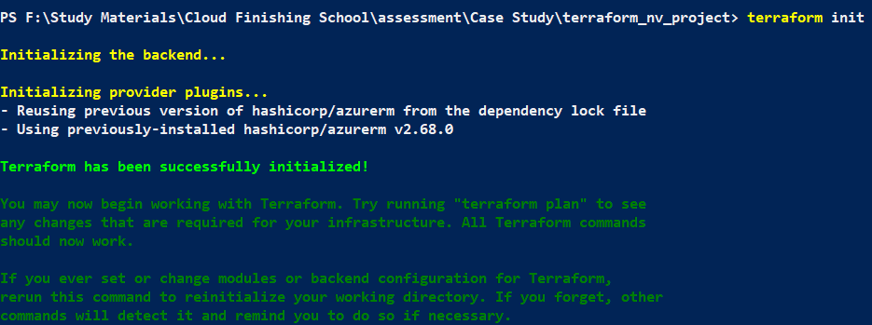





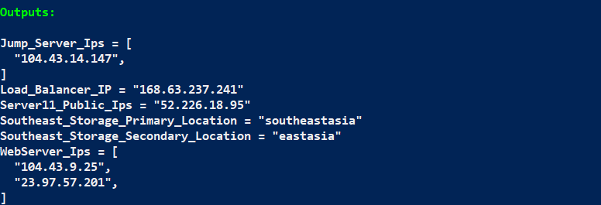

**Terraform Outputs:**

Jump_Server_Ips = [

"104.43.14.147",

]

Load_Balancer_IP = "168.63.237.241"

Server11_Public_Ips = "52.226.18.95"

Southeast_Storage_Primary_Location = "southeastasia"

Southeast_Storage_Secondary_Location = "eastasia"

WebServer_Ips = [

"104.43.9.25",

"23.97.57.201",

]

**Southeast Asia Azure Resources Diagram:**

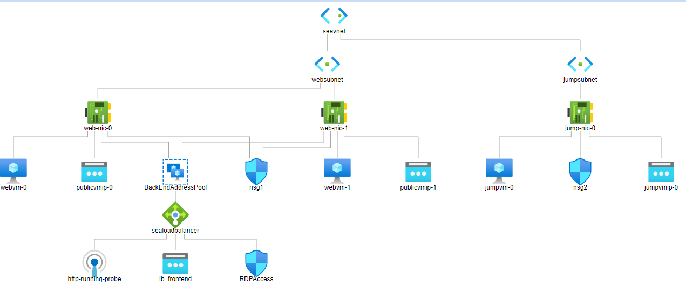

**East US Azure Resources Diagram:**

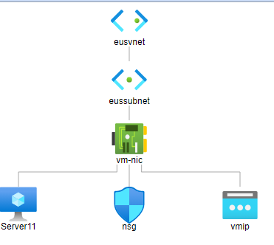

**VNet Peering:**

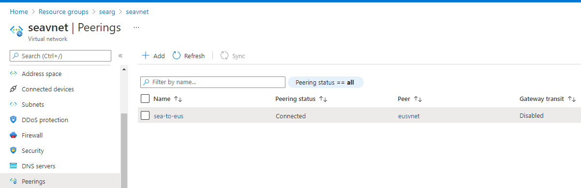

**IIS installation using Ansible from Cloud Shell:**

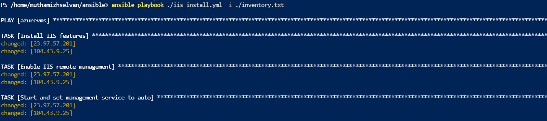

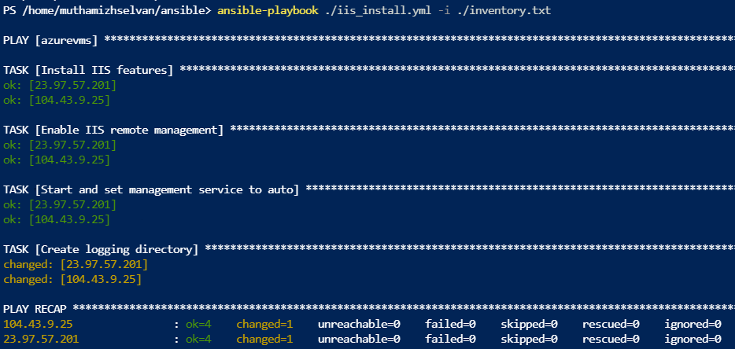

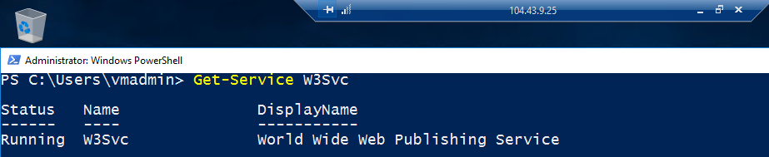

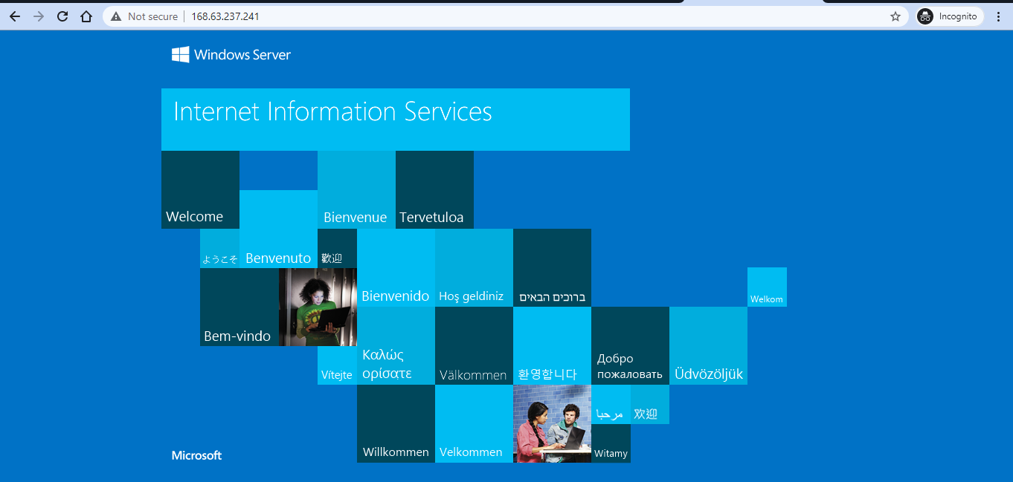

**Storage Accounts:**

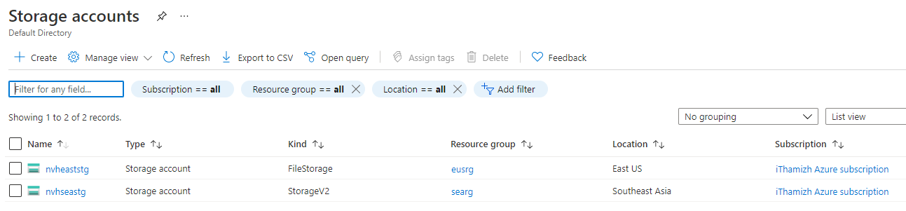

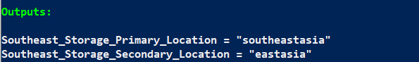

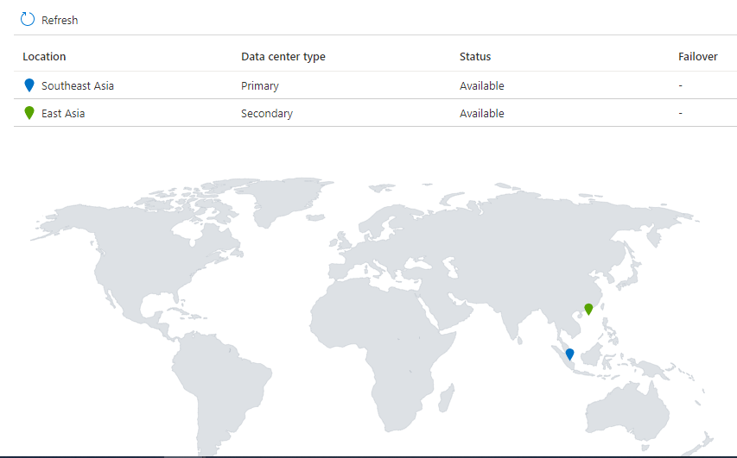

**Web Servers backup (PowerShell):**

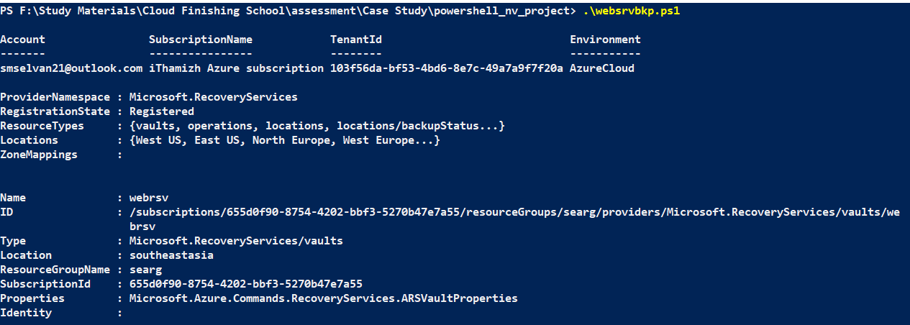

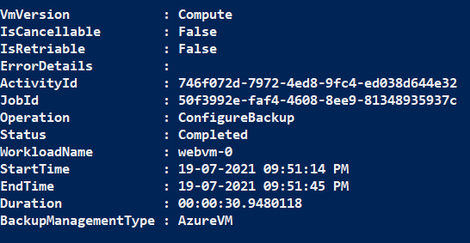

**Create alert to monitor the web server CPU utilization using PowerShell:**

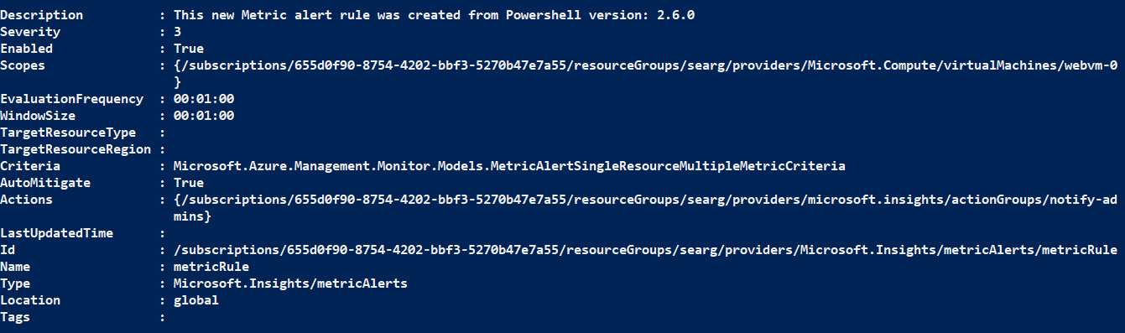

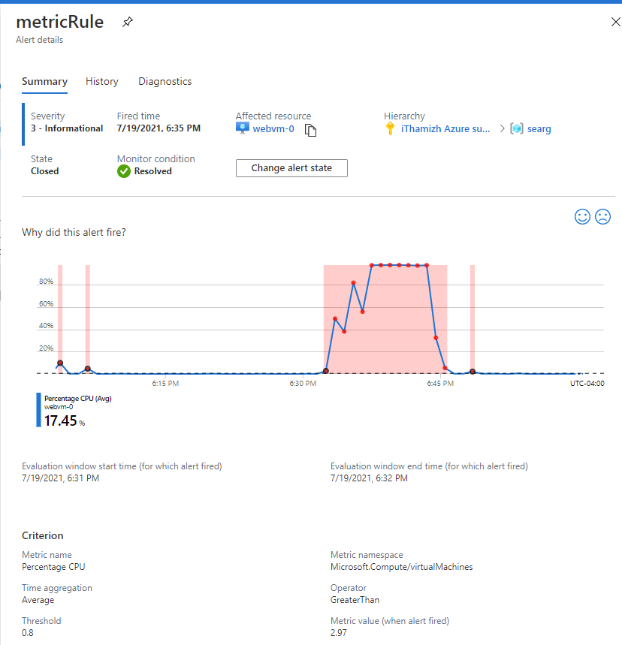

**RBAC:**

**VM Admin created using PowerShell:**

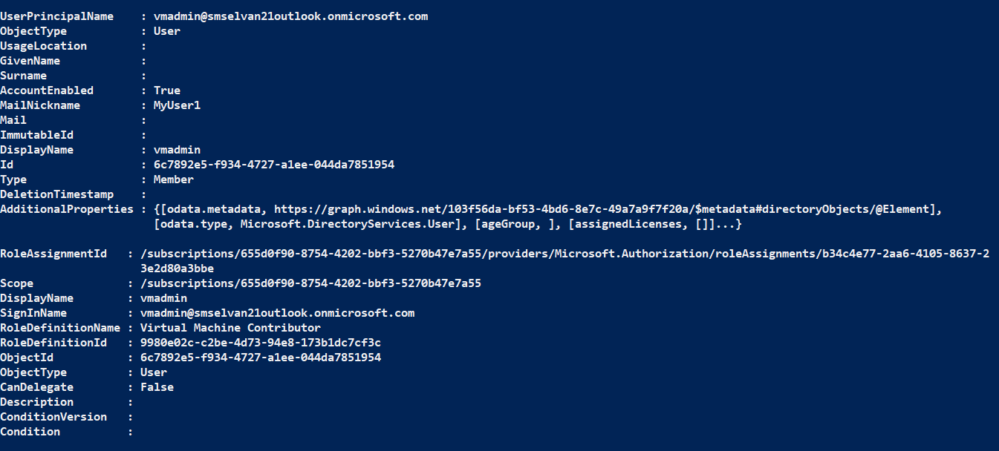

**Backup Contributor:**

